ELEG 309 - Example Problems Chapter 3-1

**Example 3.2**

Consider an *n-*typesilicon for which the dopant concentration *ND* = 1017/cm3. Find the electron and hole concentrations at *T* = 300 K.

**Example 3.3**

Find the resistivity of (a) intrinsic silicon and (b) *p*-type silicon with *NA* = 1016 /cm3. Use *ni* = 1.5 x 1010 /cm3, and assume that for intrinsic silicon *n*= 1350 cm2/Vs and *p*= 480 cm2/Vs, and for doped silicon *n*= 1110 cm2/Vs and *p*= 400 cm2/Vs. (Note that doping results in reduced carrier mobilities).

**Exercise 3.5**

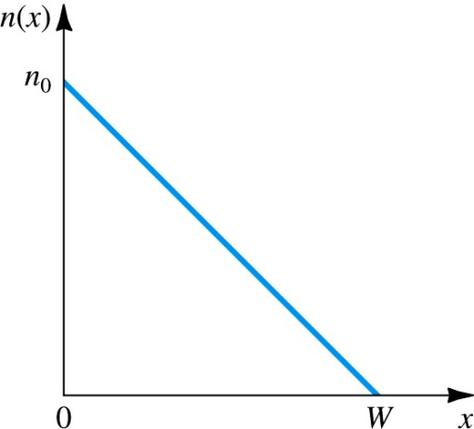The linear electron-concentration profile shown in Fig. E3.5 has been established in a piece of silicon. If *n*0= 1017 / cm3 and *W* = 1m, find the electron-current density in micro amperes per micron squared (A/m2). If a diffusion current of 1 mA is required what must the cross-sectional area (in a direction perpendicular to the page) be?

The electron diffusion current density $\left[A/{{cm}^{2}}\right]$ is:

For intrinsic silicon typical values of the diffusion constant are:

**Figure E3.5**

*Dp* = 12 cm2/s

*Dn* = 35 cm2/s